Navodila 5. razred
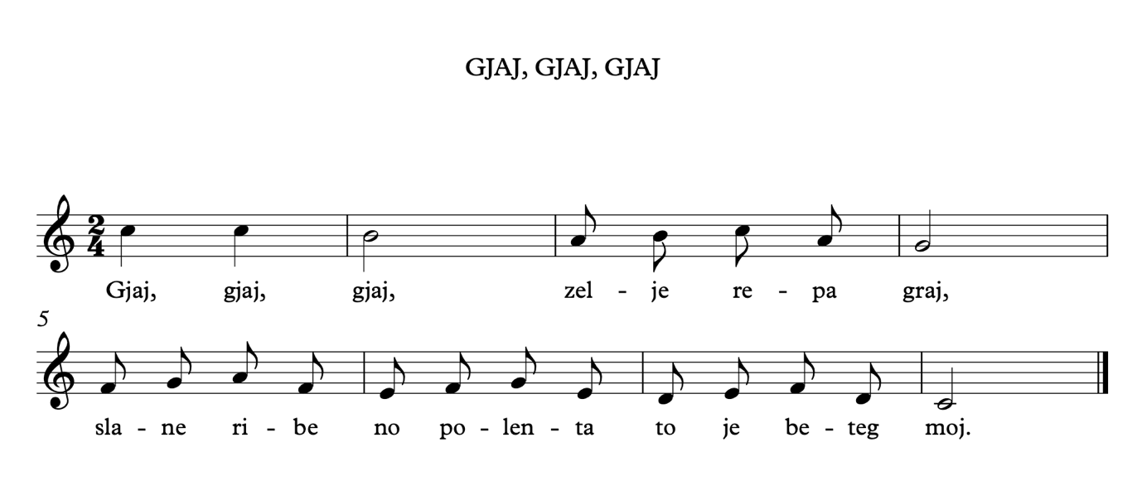

Prepis notnega zapisa:

- Nariši violinska ključa, taktnice in vpiši taktovski način.
- V notno črtovje vriši note in pod njih zapiši solmizacijske zloge (do¹, re, mi, fa, so, la, ti, do²).
______________________________________________________________________________________________________________________________________________________
______________________________________________________________________________________________________________________________________________________
______________________________________________________________________________________________________________________________________________________
____________________________________________________________________________________________________________________________________________________________________________________________________________________________________________________________________________________________________________

Gjaj, gjaj, gjaj, zel – lje re – pa graj,

______________________________________________________________________________________________________________________________________________________
______________________________________________________________________________________________________________________________________________________
______________________________________________________________________________________________________________________________________________________
____________________________________________________________________________________________________________________________________________________________________________________________________________________________________________________________________________________________________________

sla – ne ri – be no po – len – ta to je be – teg moj.

